# MÔ PHỎNG Hệ thống sử dụng điều chế qpsk qua kênh rayleigh

Hàm receiver.m

|  |
| --- |
| function chann_1=receiver(SNR_db,S_m,FS,x,S,g);  Es=var(S);  Eb=Es/2;  N_0=Eb/10^(SNR_db/10);  N0=sqrt(N_0/2)*(randn(size(FS))+j*randn(size(FS)));  NFS=(FS+N0)./g;  for i=1:length(FS)  d=abs(S_m-NFS(i));  md=min(d);  if md==d(1)  R(2*i-1)=0;  R(2*i)=0;  elseif md==d(2)  R(2*i-1)=0;  R(2*i)=1;  elseif md==d(3)  R(2*i-1)=1;  R(2*i)=1;  elseif md==d(4)  R(2*i-1)=1;  R(2*i)=0;  end  end  c=0;  for i=1:length(x)  if R(i)~=x(i)  c=c+1;  end  end  chann_1=c; |

Hàm Main của Bai2_1.m

|  |
| --- |
| clear;  x = round(rand(1,100000));  for i = 1:2:length(x)  if x(i)==0 & x(i+1)==0  S((i+1)/2)=exp(j*pi/4);  elseif x(i)==0 & x(i+1)==1  S((i+1)/2)=exp(j*3*pi/4);  elseif x(i)==1 & x(i+1)==1  S((i+1)/2)=exp(j*5*pi/4);  elseif x(i)==1 & x(i+1)==0  S((i+1)/2)=exp(j*7*pi/4);  end  end    S=S(1:20000);  x=x(1:40000);  f_m=91;  b=1/2;  N1=9;  N2=N1+1;  f1=f_m*sin(pi/2/N1*((1:N1)-1/2));  c1=sqrt(2*b/N1)*ones(size(f1));  th1=rand(size(f1))*2*pi;  f2=f_m*sin(pi/2/N2*((1:N2)-1/2));  c2=sqrt(2*b/N2)*ones(size(f2));  th2=rand(size(f2))*2*pi;  f_s=270800;  T_symb=1/f_s;  t=(0:length(S)-1)*T_symb;  g1=g(c1,f1,th1,t);  g2=g(c2,f2,th2,t);  g=g1+j*g2;  FS=g.*S;  theta_m=[pi/4,3*pi/4,5*pi/4,7*pi/4];  S_m=exp(j*theta_m);  for i=1:length(S)/4  gS_m(4*i-3:4*i)=S_m.*g(4*i-3:4*i);  end  SNR_db=0:5:30;  for i=1:length(SNR_db)  c(i)=receiver(SNR_db(i),S_m,FS,x,S,g);  end  BER=c/length(x);  save Bai2_1 BER;  semilogy(SNR_db,BER,'.--');  title('The bit error probability of QPSK over a fading channel');  xlabel('SNR in dB');  ylabel('P_b'); |

Kết quả:

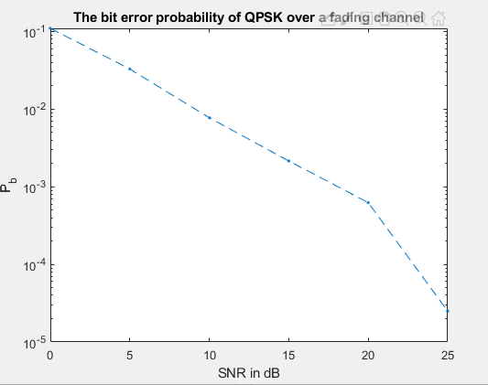

|  |
| --- |
| clear;  b=1/2;  SNR_db=0:5:30;  Y_b=2*b*10.^(SNR_db/10);  p_b=(1-sqrt(Y_b./(1+Y_b)))/2;  k=semilogy(SNR_db,p_b,'*--');  set(k,'LineWidth',1);  hold on;  load Bai2_1 BER;  semilogy(SNR_db,BER,'ro');  hold off;  title('BER of slow flat Rayleigh fading channel');  xlabel('Y_b');  ylabel('P_b');  legend('Theory','Simulation'); |

Kết quả:

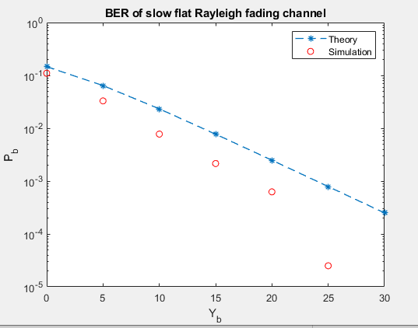

|  |  |  |  |  |  |
| --- | --- | --- | --- | --- | --- |
| SNR (dB) | 0 | 5 | 10 | 15 | 20 |
| $p_{b}$ lý thuyết | 0.1464 | 0.0641 | 0.0232 | 0.0077 | 0.0024 |
| BER mô phỏng | 0.1099 | 0.0328 | 0.0077 | 0.0021 | 0.0006 |